APACHE KAFKA
Agenda:
- Apache Kafka
  - Event in Kafka
  - Kafka topics
  - Topic partitioning
  - Brokers
  - Replication
  - Kafka consumer and consumer group
  - Kafka Producers
  - Architecture
- Zookeeper
- Kafka for Python developers
  - Installation
  - Creating a basic consumer and producer
- Kafka on confluent cloud
Apache Kafka
Apache Kafka is an event streaming platform used to collect, store, and process real-time data streams at scale. It supports various use cases, including distributed logging, stream processing, and pub-sub messaging.
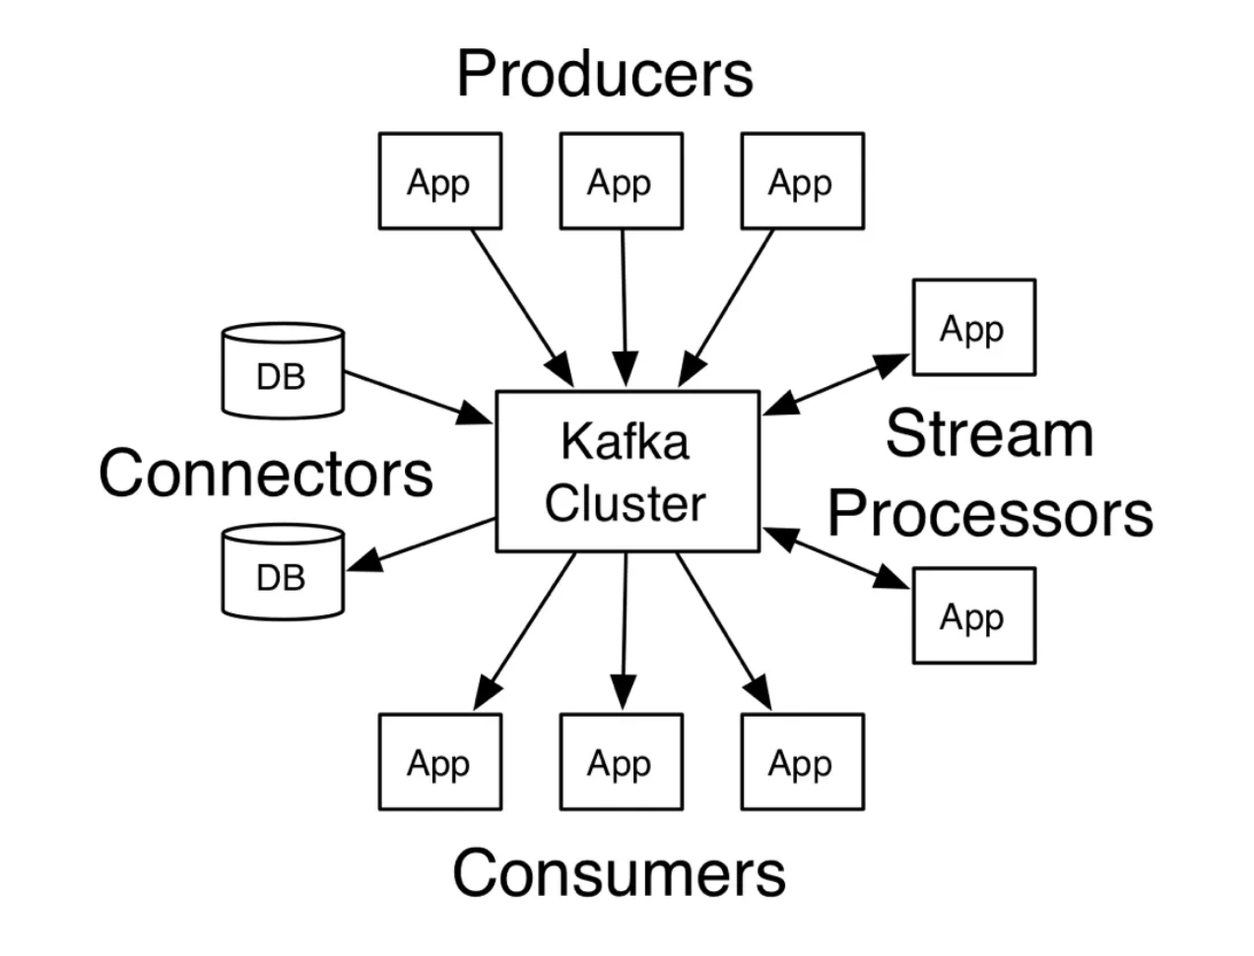
Event
- An event is a thing that has happened, combined with a description of what happened.
- Examples:
  - A smart thermostat reporting temperature and humidity.
  - A business process change, such as an invoice becoming past due.
  - A user interaction, like clicking a link.
  - A microservice completing a unit of work.
- Components:
  - Notification: Indicates when the event occurred and can trigger other activities.
  - State: Typically small (less than a megabyte), represented in structured formats like JSON, Avro, or Protocol Buffers.
Kafka's Event Data Model
- Events are modeled as key-value pairs.
- Internally, keys and values are sequences of bytes.
- Converts structured data in programming languages to Kafka's internal representation and vice versa.
  - Often represents an entity, such as a user or device ID.
  - Crucial for parallelization and data locality.
- Represents the application domain object or raw message input.
Kafka Topics
- A topic is Kafka’s fundamental unit of event organization, analogous to a table in a relational database.
  - Organizes events into containers for similar types of data.
  - Enables filtering and transforming events into different topics.
Characteristics of Kafka Topics
- Named Abstraction: Topics are the main unit developers interact with in Kafka.
- Event Logs:
  - Append-only: New messages are added to the end.
  - Immutable: Once logged, events cannot be changed.
  - Sequential Reading: Events can be read by seeking to an offset and scanning sequentially.
- Durability:
  - Logs are stored as files on disk, ensuring durability comparable to a filesystem or trusted database.
  - Retention period can be configured by age or size, ranging from seconds to years, or set to infinity.
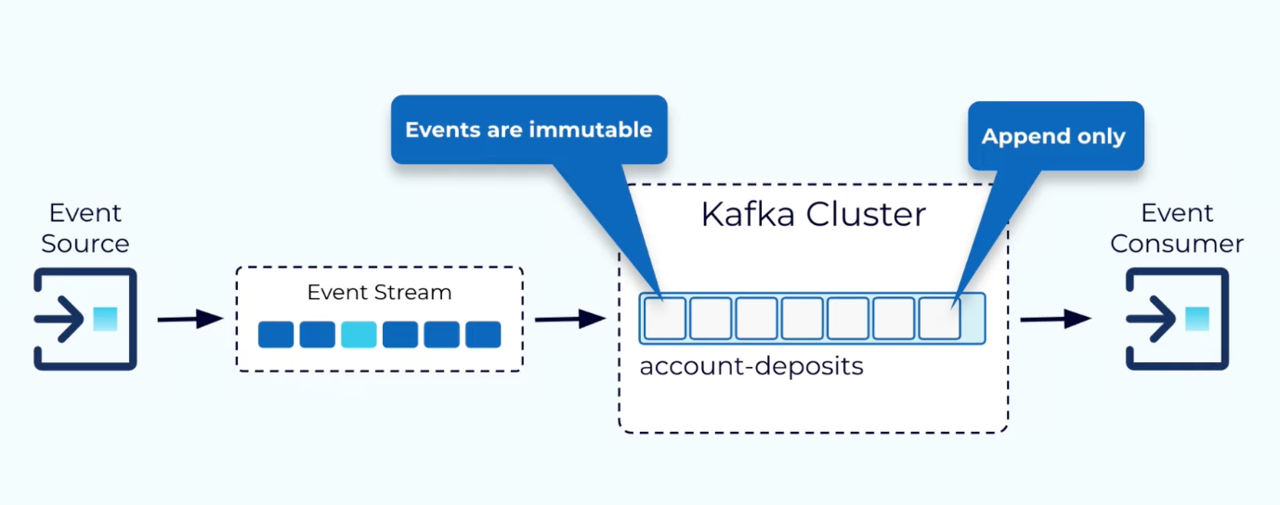
Differences Between Topics and Queues
- Temporary, ephemeral storage for buffering messages between a source and a destination.
- Kafka Topic: Durable and persistent, with no inherent temporariness. Events can be retained indefinitely.
Advantages of Logs in Kafka
- Performance:
  - Simple data structure with high throughput, even on low-resource hardware.
  - Enables replication and simplifies assumptions in distributed systems.
- Immutability:
  - Simplifies copying and distributing data.
  - Facilitates reliable and consistent architectures.
- Retention:
  - Data in topics is durable and can be retained as long as required.
Kafka Topic Partitioning
What is Partitioning?
- Partitioning splits a single topic log into multiple logs, each of which can live on separate nodes in the Kafka cluster.
- Enables Kafka to scale by distributing storage and processing across multiple nodes.
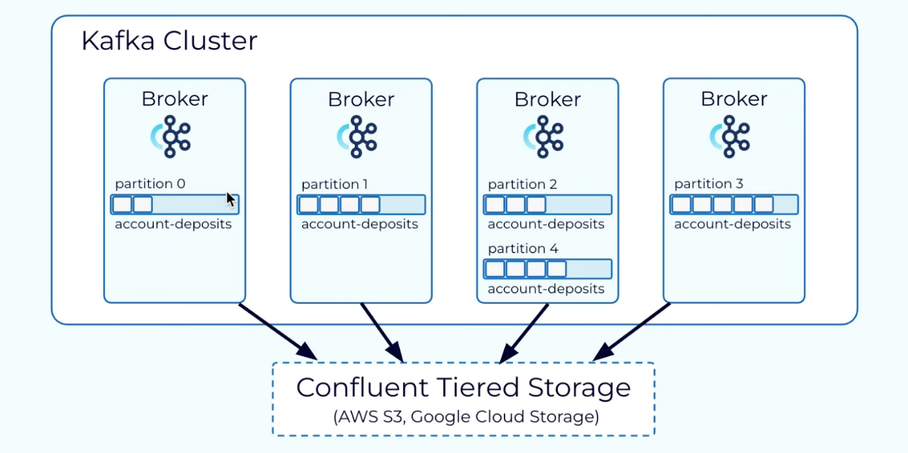
Partition Assignment
- Without a Key:
  - Messages are distributed round-robin across partitions.
  - Ensures even distribution but does not guarantee order.
- With a Key:
  - Messages are routed to partitions based on a hash of the key.
  - Guarantees that messages with the same key always land in the same partition and maintain order.
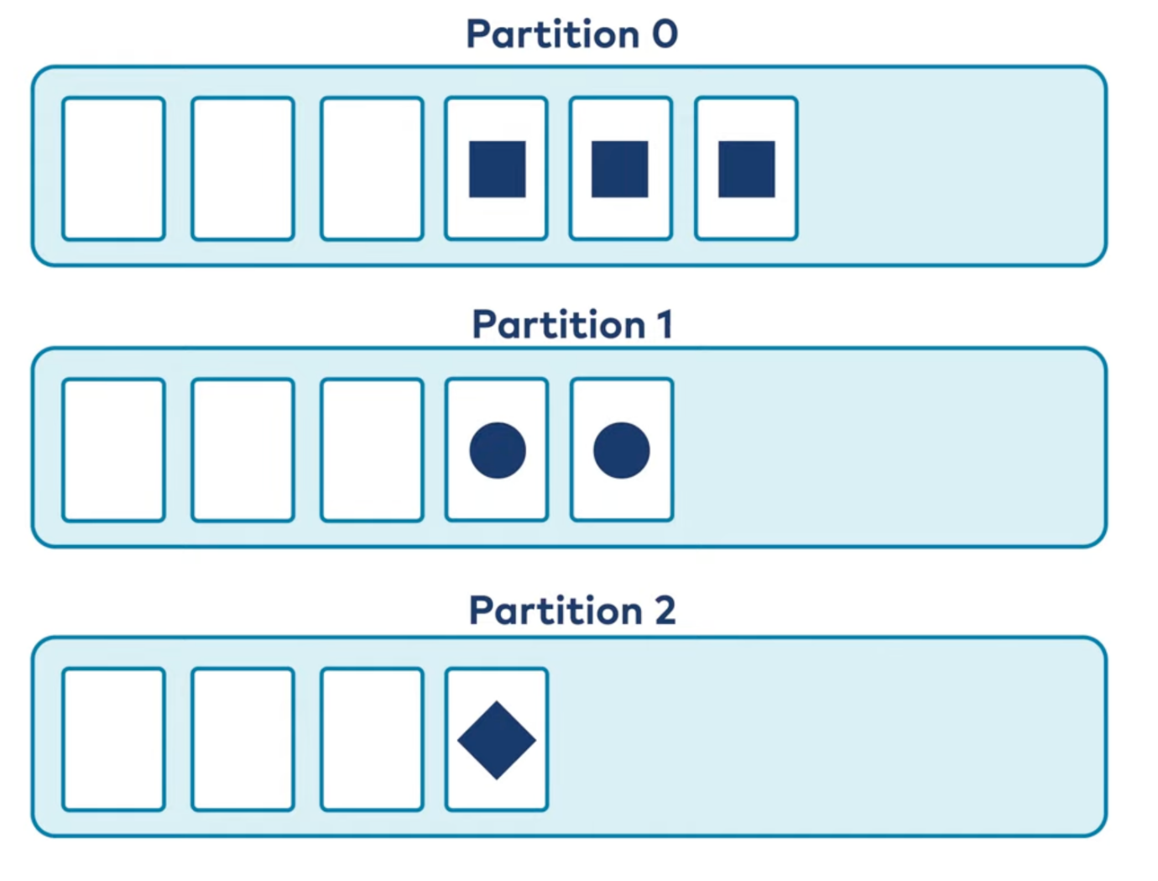
Kafka Brokers
A Kafka broker is a server instance within a Kafka cluster that handles:
- Message Storage: Stores data (records) in topics across partitions on disk.
- Message Distribution: Facilitates message delivery between producers (who send messages) and consumers (who retrieve messages).
- Cluster Coordination: Works with other brokers in the cluster to manage replication, failover, and scaling.
Each broker in the cluster is identified by a unique broker ID.
Control Plane vs. Data Plane
- Control Plane: Manages metadata (topic configs, partition assignments, replication). Uses ZooKeeper (old) or KRaft (new) for cluster coordination.
- Data Plane: Handles actual data flow, persistence, replication, and retrieval.
How Kafka Brokers Handle Requests
- Produce Requests (From Producers)
  - Assigns messages to partitions using Keyed Partitioning or Round-Robin.
  - Stores messages in record batches inside a commit log.
- Fetch Requests (From Consumers)
  - Consumers request data by specifying topic, partition, and offset.
  - Uses index structures for fast retrieval.
  - Purgatory holds requests if data isn’t available yet.
  - Uses Zero-Copy Transfer for efficient data transmission.
Replication and Durability
- Replication: Ensures fault tolerance by maintaining leader-follower replicas.
- ACKs:
  - acks=0 → No ack.
  - acks=1 → Leader ack.
  - acks=all → All in-sync replicas (ISRs) must ack.
Thread Pools in Kafka Brokers
- Network Threads: Handle requests and responses (lightweight tasks).
- IO Threads: Handle log appending, validation, and replication (heavy tasks).
Efficient Data Handling
- Commit Log: Stores each partition as a log file with Data Segments & Index Segments.
- Purgatory: Holds pending requests to optimize resource usage.
- Zero-Copy Transfer: Direct disk-to-socket data transfer for efficiency.
Kafka Replication
Kafka replication ensures high availability, fault tolerance, and durability by maintaining multiple copies of partitions across brokers.
- Partitions & Replication
  - Each topic is divided into partitions, replicated across brokers.
  - Each partition has:
    - Leader: Handles all read and write requests.
    - Followers: Replicate data from the leader but don’t serve requests unless promoted.
- Replication Factor
  - Defines the number of copies of a partition (including the leader).
  - Example: Replication factor = 3 → 1 leader + 2 followers.
- Leader Election
  - Managed by ZooKeeper (old) or KRaft (new).
  - If a leader fails, an In-Sync Replica (ISR) is promoted.
- In-Sync Replicas (ISR)
  - Followers that are fully caught up with the leader.
  - Messages are committed only when all ISRs acknowledge.
  - Lagging followers are removed from ISR until they sync back.
- Acknowledgment Levels (acks)
  - acks=0: No ack (fastest, but risky).
  - acks=1: Leader ack only.
  - acks=all: All ISRs must ack (highest durability).
Kafka Consumer
A Kafka consumer is a client application that reads records from Kafka topics. Each Kafka topic is divided into partitions, and a consumer can subscribe to one or more topics to retrieve data.
Features of Kafka Consumers
- Reads records from Kafka topics, subscribing to one or more topics.
- Offset Management: Tracks read messages using offsets, which can be automatically or manually committed.
- At-least-once Delivery: Ensures messages are not lost; reprocessing may occur if a consumer fails before committing an offset.
- Flexible Starting Points: Consumers can start reading from:
- Beginning of the topic.
- Latest messages.
- Last committed offset.
- Pull-based Model: Consumers request messages from brokers, controlling retrieval rates.
- Partition Assignment: Within a consumer group, each partition is assigned to only one consumer for sequential processing.
Kafka Consumer Group
A consumer group is a group of consumers working together to consume messages from a set of Kafka topics. It enables parallel processing and load balancing across consumers
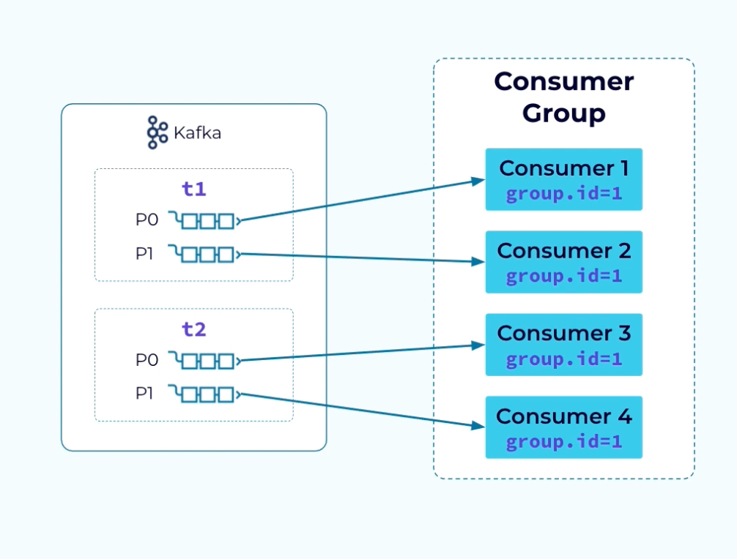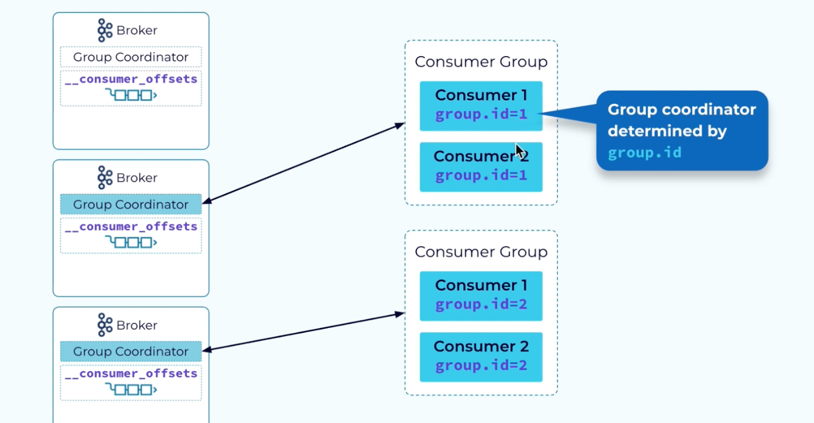
Concepts of Consumer Groups
- Parallel Processing & Load Balancing: Multiple consumers work together to consume messages from Kafka topics.
- Partition Assignment:
  - Each partition is assigned to only one consumer within the group.
  - More consumers than partitions → Some consumers remain idle.
  - More partitions than consumers → Some consumers handle multiple partitions.
- Dynamic Membership: Consumers can join/leave dynamically, triggering a rebalance process.
- Group Coordinator: A broker managing the group, tracking metadata in __consumer_offsets.
How a Consumer Group Works
- Joining a Group: Consumers send a Join Group request; one is chosen as the leader for partition assignment.
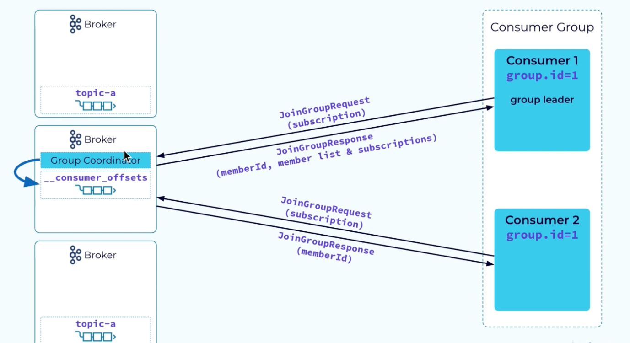
- Partition Assignment: The leader distributes partitions using strategies like Range, Round Robin, Sticky, or Cooperative Sticky.
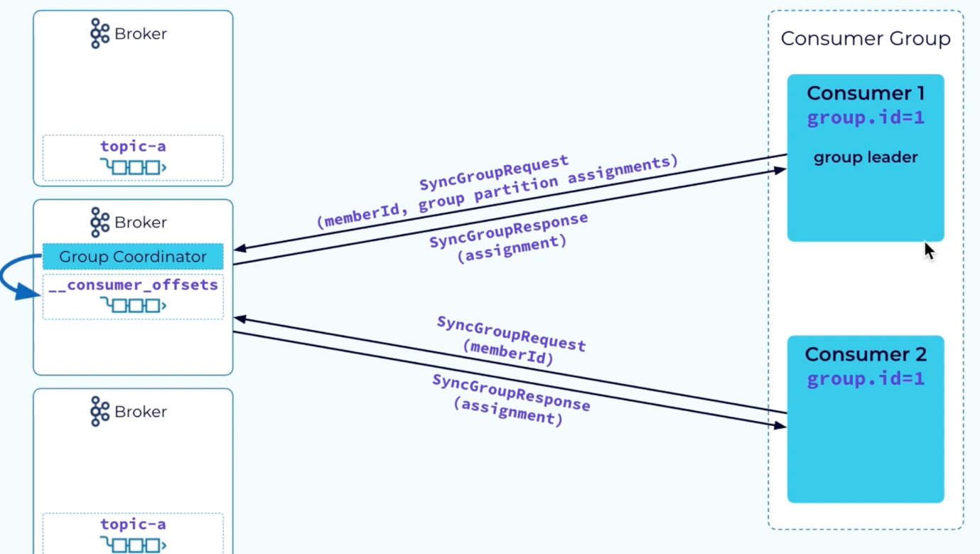
- Processing Messages: Each consumer independently fetches and processes messages.
- Offset Tracking:
  - Auto-commit (configurable time interval).
  - Manual commit (greater control over checkpointing).
Partition Assignment Strategies
- Range: Sequential partition assignment per topic.
- Round Robin: Even distribution across consumers, maximizing parallelism.
- Sticky: Minimizes reassignment during rebalances.
- Cooperative Sticky: Reduces rebalance disruptions by retaining partitions.
Offset Management in Consumer Groups
- Durable tracking via __consumer_offsets topic.
- Static Membership: Assigns a static member ID to prevent unnecessary rebalances when a consumer disconnects temporarily.
Rebalance Process
- Coordinator notifies consumers of a rebalance.
- Consumers revoke partitions and wait for a new assignment.
- The leader assigns partitions based on the strategy.
- Consumers receive assignments and resume processing.
Advantages of Consumer Groups
- Scalability: Adding more consumers increases throughput.
- Fault Tolerance: If a consumer fails, its partitions are reassigned.
- Load Balancing: Even distribution of partitions among consumers.
- Parallel Processing: Consumers process data concurrently.
Use Cases
- Event-driven Architectures (e.g., real-time order processing).
- Data Processing Pipelines (e.g., Apache Flink, Kafka Streams).
- Analytics & Monitoring (e.g., log aggregation).
- Microservices Communication (e.g., sharing data between services).
Kafka Producers
Role of the Producer
- Sends events (key-value pairs) to Kafka topics.
- Partitioning: Determines which partition receives the event.
- Acknowledgments: Waits for confirmation from brokers for message delivery.
Producer Workflow
- Create a Producer Instance
  - Use KafkaProducer (Java, Python, Go, etc.).
  - Configure broker addresses, serialization formats, and acks.
- Prepare the Event
  - Use ProducerRecord (contains topic, key, value, and timestamp).
- Send the Event
  - Producer sends data asynchronously with buffering, retries, and acknowledgments.
- Partition Assignment
  - No key → Round-robin distribution.
  - With key → Hashing algorithm assigns partition.
  - Custom logic → Implement a custom partitioner if needed.
Features of Kafka Producers
- Asynchronous Sending: Messages are sent asynchronously for better performance.
- Retries & Idempotence:
  - Retries messages if delivery fails.
  - enable.idempotence=true ensures exactly-once delivery.
- Compression: Reduces network overhead using gzip, Snappy, or LZ4.
Partitioning Strategies
- Round-robin: Distributes messages evenly if no key is provided.
- Key-based hashing: Assigns partitions using the key’s hash value.
- Custom partitioning: Implement custom logic if needed.
Producer Configuration Parameters
- bootstrap_servers: List of Kafka brokers (localhost:9092).
- acks:
  - 0 → No acknowledgment (fastest, but risky).
  - 1 → Leader acknowledgment only.
  - all → All replicas must acknowledge (highest durability).
- key_serializer & value_serializer: Convert keys/values to byte arrays.
- retries: Number of retry attempts for failed sends.
- linger_ms: Time (ms) before sending a batch (improves efficiency).
- batch_size: Maximum size (bytes) of a batch before sending.
Example (Python Producer)
from kafka import KafkaProducer
producer = KafkaProducer(
bootstrap_servers='localhost:9092', # Kafka broker address
acks='all', # Wait for all replicas to acknowledge
key_serializer=str.encode, # Convert keys to bytes
value_serializer=str.encode, # Convert values to bytes
retries=3, # Retry failed sends up to 3 times
linger_ms=1, # Small delay before sending batches
batch_size=16384 # Max batch size (bytes)
)
Kafka Architecture
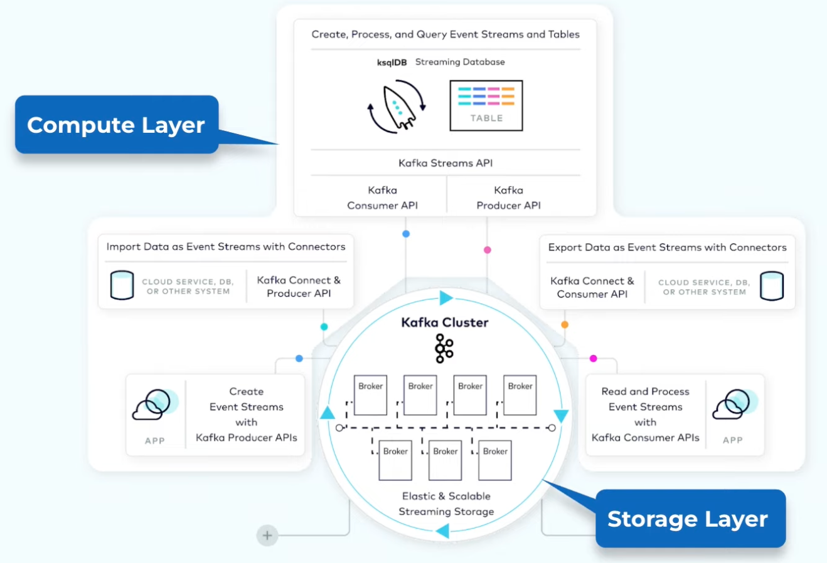
- Kafka is an event streaming system designed for real-time processing, allowing applications to act on events as they occur.
- At its core, Kafka uses a distributed log storage system that efficiently stores data as ordered logs and scales horizontally to meet growing demands.
- Producers publish events into Kafka topics, while consumers read events from these topics, enabling decoupled communication between systems.
- Topics are divided into partitions for parallelism and scalability, with each partition replicated across brokers to ensure fault tolerance and durability.
- Kafka brokers handle the storage of partitions, manage replication, and process client requests, forming a distributed cluster.
- Kafka Connect integrates Kafka with external systems, using source connectors to ingest data and sink connectors to export data.
- Kafka Streams provides a Java library for building real-time processing applications, while KSQL offers a declarative SQL-like interface for event processing.
- The system ensures reliability through replication, acknowledgments, retries, and robust offset management for message consumption.
- Kafka's architecture separates storage from processing, allowing each layer to scale independently based on specific needs.
- Designed for fault tolerance and scalability, Kafka enables event-driven architectures with high throughput and low latency.
Zookeeper in Apache Kafka
Zookeeper is an integral component of Apache Kafka's architecture (in older versions), acting as a distributed coordination service. It plays a crucial role in managing Kafka's cluster-wide configuration, metadata, and synchronization.
Tasks Zookeeper Performs in Apache Kafka
- Electing a Controller:
  - One of the Kafka brokers is elected as the controller.
  - The controller manages the leader/follower relationship for partitions.
  - If a node shuts down, the controller tells other replicas to become leaders.
  - Zookeeper ensures there is always only one controller at any given time.
- Cluster Membership:
  - Tracks in which Kafka brokers are alive and part of the cluster.
  - Keeps the Kafka cluster informed of active nodes.
- Topic Configuration:
  - Manages metadata for Kafka topics:
    - Number of partitions.
    - Replication factor.
    - Location of replicas.
    - Preferred partition leaders.
- Manage Quotas:
  - Tracks and enforces client quotas to control how much data each client can read or write.
- Access Control:
  - Maintains information about who can read/write to topics.
  - Tracks consumer group membership and offsets.
Kafka for python developers:
Installing Apache Kafka on Windows and implementing a basic Kafka Consumer and Producer with Python:
Step 1: Download Apache Kafka
- Go to the official Apache Kafka website: https://kafka.apache.org/downloads.
- Under "Binary Downloads," select the latest Kafka version and download the .tgz file.
- Extract the .tgz file twice (first to .tar and then the folder). You'll get a folder named kafka_x.x.x.
Step 2: Set Up Kafka on Windows
- Move Kafka Folder:
  - Move the extracted folder to a preferred directory (e.g., C:\kafka).
- Create Folders for Zookeeper and Kafka Logs:
  - Inside the C:\kafka folder, create two subfolders:
    - zookeeper (for Zookeeper data)
    - logs (for Kafka logs)
- Configure Zookeeper:
Navigate to C:\kafka\config\zookeeper.properties and edit the following lines:
dataDir=C:/kafka/zookeeper
Set maxClientCnxns to 1 for this example:
maxClientCnxns=1
- Configure Kafka:
Navigate to C:\kafka\config\server.properties and edit the following lines:
log.dirs=C:/kafka/logs
- Leave other configurations as default for now.
Step 3: Start Kafka Services
- Start Zookeeper:
  - Open a command prompt and navigate to C:\kafka\bin\windows.
Run the following command to start Zookeeper:
zookeeper-server-start.bat ../../config/zookeeper.properties
- Start Kafka Server:
Open another command prompt, navigate to C:\kafka\bin\windows, and run:
kafka-server-start.bat ../../config/server.properties
Step 4: Create a Topic
Open a new command prompt, navigate to C:\kafka\bin\windows, and run:
kafka-topics.bat --create --topic test-topic --bootstrap-server localhost:9092 --partitions 1 --replication-factor 1
To list all topics:
kafka-topics.bat --list --bootstrap-server localhost:9092
Step 5: Basic Implementation in Python
Install Kafka Python Library
pip install kafka-python
Producer Code
from kafka import KafkaProducer
import json
# Create a Kafka producer
producer = KafkaProducer(
bootstrap_servers='localhost:9092',
value_serializer=lambda v: json.dumps(v).encode('utf-8') # Serialize data to JSON
)
# Send messages to Kafka
for i in range(5):
producer.send('test-topic', {'number': i})
print(f"Message {i} sent")
producer.flush() # Ensure all messages are sent
producer.close()
Explanation:
- KafkaProducer:
  - Responsible for sending messages to a Kafka topic.
  - The bootstrap_servers parameter specifies the Kafka broker address (localhost:9092 in this case).
- value_serializer:
  - Kafka works with byte arrays. The producer serializes Python objects (e.g., dictionaries) into JSON strings and encodes them as bytes before sending them to Kafka.
- producer.send(topic, value):
  - Send a message to the specified topic.
  - The value is the message payload, serialized earlier using value_serializer.
- for i in range(5):
  - This loop sends 5 messages ({'number': 0}, {'number': 1}, etc.) to the topic.
- producer.flush():
  - Ensures all buffered messages are sent to Kafka before proceeding.
- producer.close():
  - Closes the producer instance and releases any associated resources.
Consumer Code
from kafka import KafkaConsumer
import json
# Create a Kafka consumer
consumer = KafkaConsumer(
'test-topic',
bootstrap_servers='localhost:9092',
auto_offset_reset='earliest', # Read messages from the beginning
value_deserializer=lambda v: json.loads(v.decode('utf-8')) # Deserialize JSON
)
# Read messages from the topic
print("Reading messages from the topic...")
for message in consumer:
print(f"Received: {message.value}")
Explanation:
- KafkaConsumer:
  - Used to read messages from a Kafka topic.
- Topic:
  - The consumer subscribes to the test-topic.
- auto_offset_reset:
  - 'earliest': Reads messages from the beginning of the topic if the consumer has no prior offset.
  - 'latest': Reads only new messages after the consumer starts.
- value_deserializer:
  - Converts the bytes received from Kafka back into JSON strings and then parses them into Python objects.
- for message in consumer:
  - Continuously listens for new messages in the topic.
- message.value:
  - Retrieves the deserialized payload of the Kafka message.
- Output Example:
If the producer sends messages like {'number': 0}, {'number': 1}, the consumer prints:
Received: {'number': 0}
Received: {'number': 1}
Step 6: Running the Code
- Start the Kafka Producer script to send messages to the topic.
- Start the Kafka Consumer script to read messages from the topic.
Workflow Summary
- Producer:
  - Creates messages and sends them to the Kafka topic (test-topic).
- Kafka Broker:
  - Acts as an intermediary that stores the messages sent by the producer.
- Consumer:
  - Reads messages from the Kafka topic and processes them.
Summary:
Major command line prompts to keep in mind:
- zookeeper-server-start.bat ..\..\config\zookeeper.properties
- kafka-server-start.bat ..\..\config\server.properties
- kafka-topics.bat --create --topic my-topic --bootstrap-server localhost:9092 --replication-factor 1 --partitions 3
- kafka-console-producer.bat --broker-list localhost:9092 --topic my-topic
- kafka-console-consumer.bat --bootstrap-server localhost:9092 --topic my-topic --from-beginning
These commands represent a basic workflow for setting up and interacting with Apache Kafka on a local machine:
- Start Zookeeper to manage the Kafka cluster.
- Start the Kafka broker that will handle message storage and distribution.
- Create a topic in Kafka to organize messages.
- Use a console producer to send messages to the topic.
- Use a console consumer to read messages from the topic.
This setup allows you to test and understand the basic operations of Kafka, including producing and consuming messages in a straightforward manner.
Using a Confluent cloud (Alternative method):
Setting up a Confluent Cloud account to use Apache Kafka with Python involves several steps, from creating your account to configuring your environment. Here’s a detailed explanation of the process:
Step 1: Create a Confluent Cloud Account
- Visit the Sign-Up Page: Go to the Confluent Cloud sign-up page.
- Fill in Your Details:
  - Enter your name, email, and password. Make sure to remember these credentials, as you will need them to log in later.
- Start Free Trial: Click the Start Free button. This will lead you to a confirmation page.
- Confirm Your Email: Check your inbox for a confirmation email from Confluent. Click the link in the email to confirm your account.
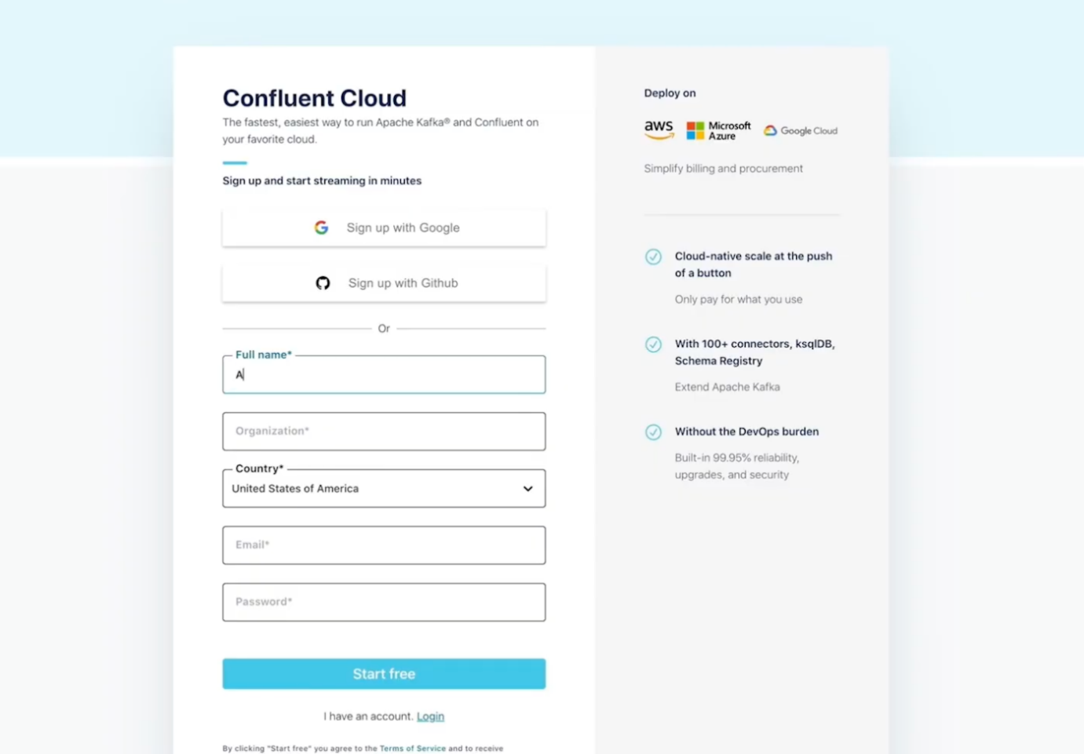
Step 2: Set Up Your Kafka Cluster
- Choose Your Cluster Type: After confirming your email, you'll be prompted to set up your Kafka cluster. You can choose between:
  - Basic Cluster: This is a serverless offering suitable for most users. It allows you to use resources based on your needs and is perfect for the exercises in your course.
  - Standard Cluster: This offers more features and dedicated resources, but might incur higher costs.
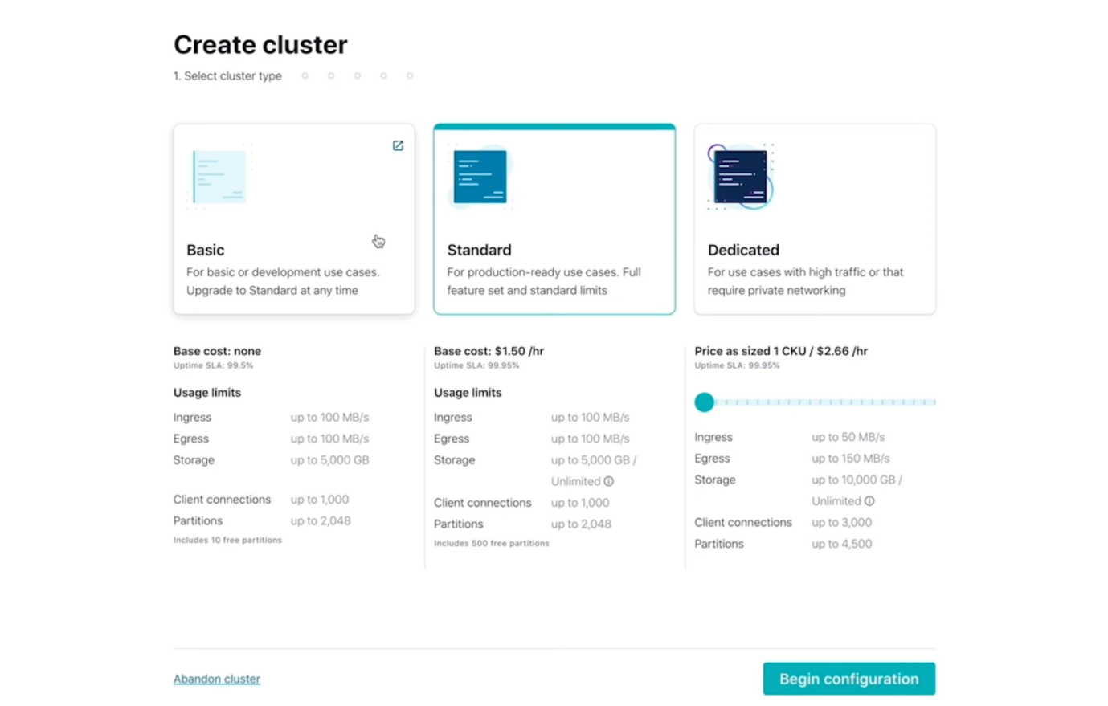
- Cluster Configuration:
  - Select the Basic Cluster for the exercises.
  - Review the cost information shown at the bottom of the screen to understand potential charges.
  - Give your cluster a name and click Review.
- Provision the Cluster: Click Launch to create your cluster. This may take a few minutes to provision.
- Wait for Email Confirmation: You will receive an email once your cluster is fully provisioned.
Step 3: Apply Promo Code for Free Usage
- Access Billing and Payment: In your Confluent Cloud dashboard, navigate to Settings > Billing and Payment.
- Apply Promo Code:
  - Enter any promotional codes you may have to get additional free usage credits.
  - You can also add a credit card here if you want to ensure continued service after your free credits are exhausted.
Step 4: Set Up Your Python Environment
Install Confluent Python Client: Open your terminal or command prompt and install the Confluent Kafka Python package by running:
pip install confluent-kafka
- Configure Your Environment: Make sure to set up your Python script to connect to your Confluent Cloud Kafka cluster. You will need the following configuration details:
  - Bootstrap Servers: The address of your Kafka cluster (found in the Confluent Cloud dashboard).
  - API Key and Secret: Generated in the Confluent Cloud dashboard under your cluster settings for authentication.
Example Code to Produce and Consume Messages
Example of how to produce and consume messages using Python with Confluent Kafka:
Producer Example:
from confluent_kafka import Producer
# Configure the producer
conf = {
'bootstrap.servers': 'your_bootstrap_server', # Replace with your cluster's bootstrap server
'security.protocol': 'SASL_SSL',
'sasl.mechanism': 'PLAIN',
'sasl.username': 'your_api_key', # Replace with your API key
'sasl.password': 'your_api_secret' # Replace with your API secret
}
producer = Producer(conf)
# Produce a message
producer.produce('my-topic', key='key', value='Hello, Kafka!')
producer.flush()
Consumer Example:
from confluent_kafka import Consumer
# Configure the consumer
conf = {
'bootstrap.servers': 'your_bootstrap_server', # Replace with your cluster's bootstrap server
'group.id': 'my-group',
'auto.offset.reset': 'earliest',
'security.protocol': 'SASL_SSL',
'sasl.mechanism': 'PLAIN',
'sasl.username': 'your_api_key', # Replace with your API key
'sasl.password': 'your_api_secret' # Replace with your API secret
}
consumer = Consumer(conf)
consumer.subscribe(['my-topic'])
# Consume messages
while True:
msg = consumer.poll(1.0) # Wait for message or timeout
if msg is None:
continue
if msg.error():
print(f"Consumer error: {msg.error()}")
continue
print(f"Received message: {msg.value().decode('utf-8')}")
consumer.close()

